Name: ____________________________ Surname: ____________________________ N^{ber}: ____ Grade/Class: _____
Assessment: _____________________________ | Date: ___________________________________________________
 | Teacher’s signature:  ___________________________ | Parent’s signature:  ___________________________

Describe your home. Complete the sentences about you and your home. Remember to use a, an or the in front of the nouns when needed.

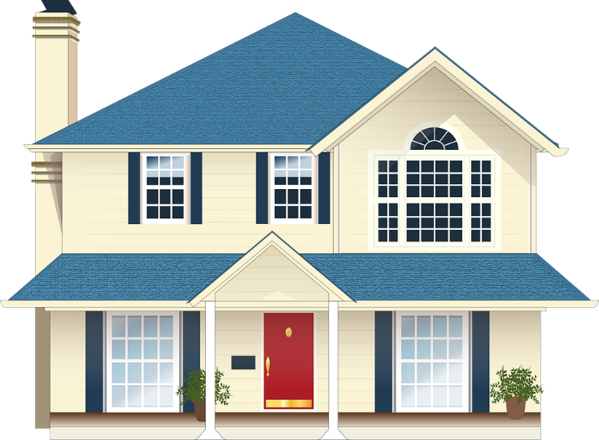
My home

Hello! My name is _________________. I am _________________ years old. I live with my _________________ (family members). I live in _________________ (city). My home is _________________ (size). We have _________________ (where you cook), _________________ (where you watch TV) and _________________ (how many) _________________ (where you sleep). We also have _________________ (how many) _________________ (where you wash yourself and brush your teeth)
My favorite room in our home is _________________.
In my room I have _________________, _________________ and _________________ (furniture). On the floor I have _________________.
We don’t have _________________ or _________________.

