Name: ____________________________ Surname: ____________________________ N^{ber}: ____ Grade/Class: _____
Assessment: _____________________________ | Date: ___________________________________________________
 | Teacher’s signature:  ___________________________ | Parent’s signature:  ___________________________

- Listen, match and then color the pictures.
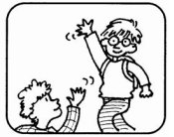

good morning

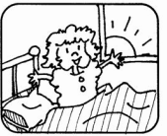 good night
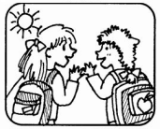 good evening
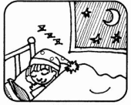

good afternoon

Script:
- A: Good afternoon mom!
B: Good afternoon son!
- A: Good morning class!
B: Good morning teacher!
- A: Good night Charlie!
B: Good night Sam!
- A: Good evening Mr Simpson!
B: Good evening Emily!

