Name: ____________________________ Surname: ____________________________ N^{ber}: ____ Grade/Class: _____
Assessment: _____________________________ | Date: ___________________________________________________
 | Teacher’s signature:  ___________________________ | Parent’s signature:  ___________________________

1. Listen and number

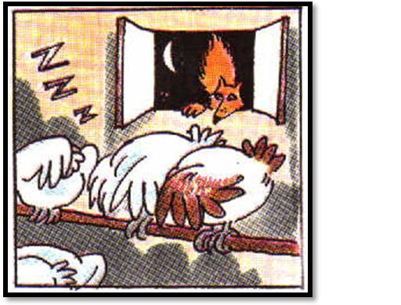

____________ ____________

____________ ____________

Script
- Good afternoon everybody!
- Good morning girls!
- Good night !
- Good evening, let’s have dinner!

