Name: ____________________________ Surname: ____________________________ N^{ber}: ____ Grade/Class: _____
Assessment: _____________________________ | Date: ___________________________________________________
 | Teacher’s signature:  ___________________________ | Parent’s signature:  ___________________________

- Listen and tick.
A.
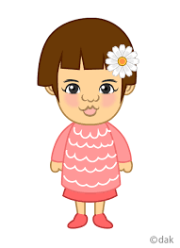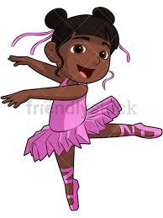

B.

Script:
A. Hi, my name’s Melisa. I’m 2 years old. I’m from Turkey, I’m Turkish.

B. Hello, my name’s Haruki. I’m 10 years old. I’m from Japan. I’m Japanese.

