TOPIC: | SUBTOPICS: | LEVEL:
Name: ____________________________ Surname: ____________________________ N^{ber}: ____ Grade/Class: _____
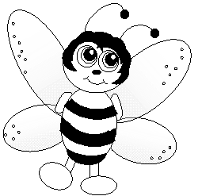
Help the bee find the way to its friend! Reconstruct their dialogue by coloring the correct spaces.

I’m Maya!
Nice to meet you!
How are you?
I’m fine, thanks!
Where do you live?
I live in a hive.
How old are you?
I’m one.
Thank you!
Hello!
I’m fine!
Thank you!
Hello!
What’s your name?
My name’s Bee!
What’s your name?
START
Nice to meet you, too!
How old are YOU?
I’m one, too.
Can you fly?
Yes, I can.
Look!
See you later! Bye!
Where are you?
I’m here!
Goodbye!
FINISH
I’m fine!
I’m happy!
Thank you!
I’m fine!
Hello!
I’m fine!

