Name: ____________________________ Surname: ____________________________ N^{ber}: ____ Grade/Class: _____
Assessment: _____________________________ | Date: ___________________________________________________
 | Teacher’s signature:  ___________________________ | Parent’s signature:  ___________________________

Read and Match.
Good morning!
My name’s Jack.
I’m from England. I’m 6.
Good afternoon!
My name’s Maya. I’m from Italy. I’m 10 years old.
Good evening! My name’s Fatima. I’m from Saudi Arabia. I’m 18.
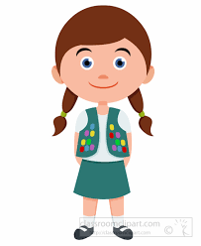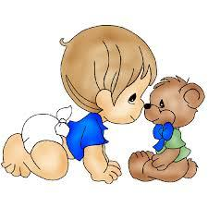
Good night!
Myname’s Pablo. I’m from Portugal. I’m 2 years old.
Answer Key
Good morning!
My name’s Jack.
I’m from England. I’m 6.
Good afternoon!
My name’s Maya. I’m from Italy. I’m 10 years old.
Good evening! My name’s Fatima. I’m from Saudi Arabia. I’m 18.
Good night!
Myname’s Pablo. I’m from Portugal. I’m 2 years old.

