TOPIC: | SUBTOPICS: | LEVEL:
Name: ____________________________ Surname: ____________________________ N^{ber}: ____ Grade/Class: _____
FINGER PUPPETS

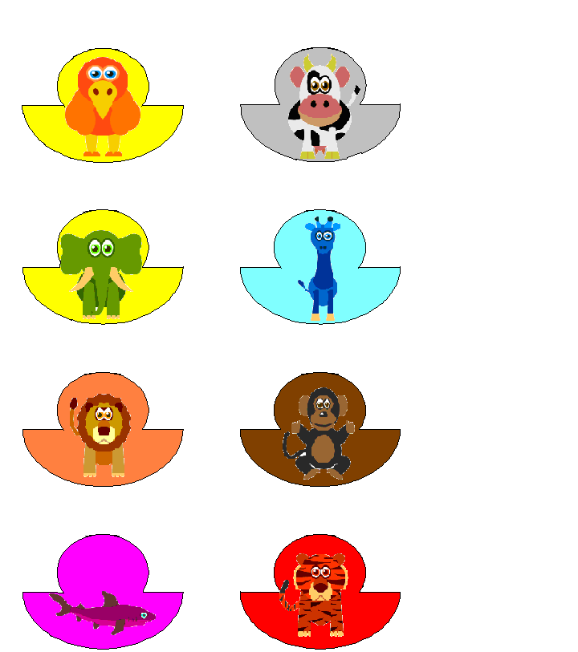
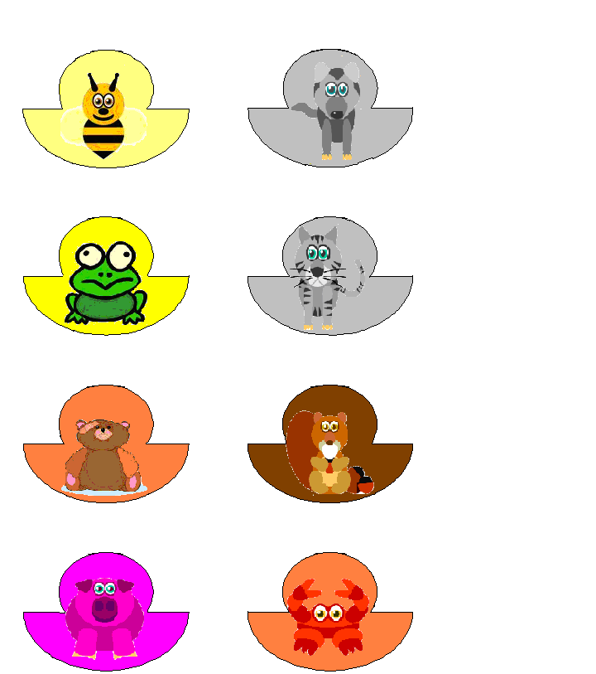

- Cut the puppets along the lines
- Roll the half circle part of each pieces and adjust the circumference according to your finger size. Paste the edges together.
3. Put the puppets onto your finger and play.

