TOPIC: Introducing | EXAM: Flag show and tell | LEVEL: A1
Name: ____________________________ Surname: ____________________________ N^{ber}: ____ Grade/Class: _____

 | LEVELS OF PROFICIENCY |  |  | SCORE
 | NEEDS IMPROVEMENT | DEVELOPING | EXCELLENT
CRITERIA | 1 point | 2 points | 3 points
INTERACTION | Reveals difficulties in interaction. | Good at interaction. | Interaction at perfection level.
VOCABULARY  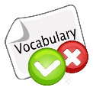 | Reveals a lack of vocabulary knowledge. | Reveals a satisfactory vocabulary knowledge. | Reveals an excellent vocabulary knowledge.
GESTURES AND BODY LANGUAGE  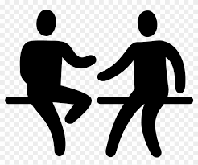 | Difficulties in understanding the pictures and miming them. | Satisfactory level of understanding and expressing the content of the pictures. | Clearance at understanding and expressing the content of the pictures
PRONUNCIATION | Unclear speech and mispronunciation. | The clarity of speech is satisfactory, some mistakes on the pronunciation of words. | Speaks clearly and makes no mistake on the pronunciation of words.
TASK | Difficulties in understanding the task | Understands the task, but problems at fulfilling it | Completes the given task requirements
 |  |  | Total Score | __/15
 |  |  | Percentage ✶ | ___%

