Name: ____________________________ Surname: ____________________________ N^{ber}: ____ Grade/Class: _____
Assessment: _____________________________  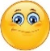 | Date: ___________________________________________________
 | Teacher’s signature:  ___________________________ | Parent’s signature:  ___________________________

- Look and say the correct greeting to your partner

Student A

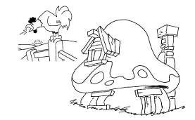

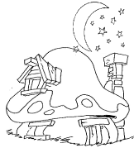
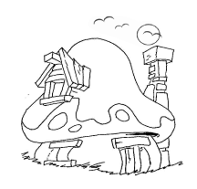

- Look and say the correct greeting to your partner

Student B

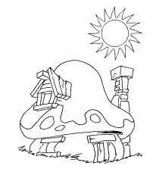

Answer Key
Student A

Good morning

Good night

Answer Key
Student B

Good afternoon

Good evening

