Name: ____________________________ Surname: ____________________________ N^{ber}: ____ Grade/Class: _____
Assessment: _____________________________  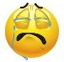  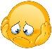 | Date: ___________________________________________________
 | Teacher’s signature:  ___________________________ | Parent’s signature:  ___________________________

Match the countries with the pictures

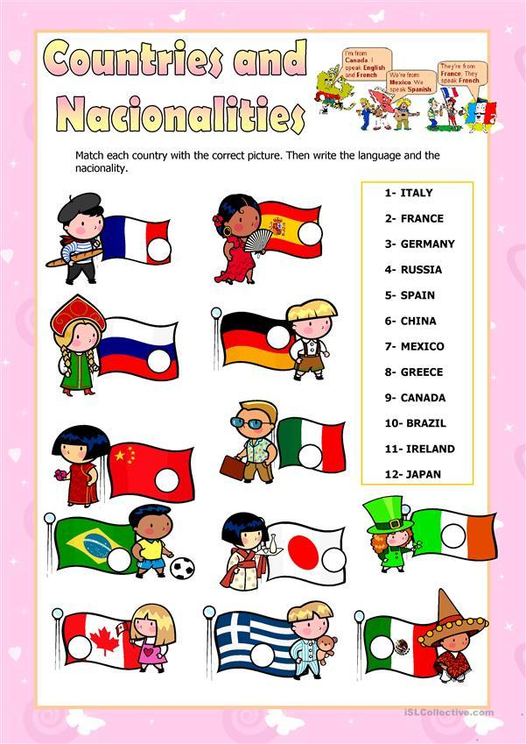

Answer Key
22
4
6
102
11
12
72
8
9
52
3
1

