Name: ____________________________ Surname: ____________________________ N^{ber}: ____ Grade/Class: _____
Assessment: _____________________________ | Date: ___________________________________________________
 | Teacher’s signature:  ___________________________ | Parent’s signature:  ___________________________

- Write the answers.
2 + 5 = Seven
4 + 4 = ..........

2 + 3 = ..........
2 + 7 = ..........
3 + 1 = ........
1 + 5 = ..........
2 + 1 = ..........
9 + 1 = ..........

- Fill in the gaps
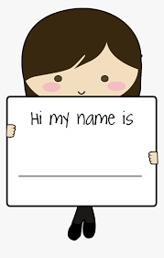
_ _
__ __ __ __
My __ __ __ __ is
Answer Key
- Write the answers.
2 + 5 = Seven
4 + 4 = eight

2 + 3 = five
2 + 7 = nine
3 + 1 = four
1 + 5 = six
2 + 1 = three
9 + 1 = ten

- Fill in the gaps
_ _
How are you
Good bye
My name is

