TOPIC: | SUBTOPICS: | LEVEL:
Name: ____________________________ Surname: ____________________________ N^{ber}: ____ Grade/Class: _____

A-FILL IN THE BLANKS

- G - - - M - - - - - - !
- H - - - - !
- G - - - B - - !
- G - - - A - - - - - - - - !
- G - - - E - - - - - - !
- G - - - N - - - - !
- W - - - I - Y - - - N - - - ?
- H - - A - - Y - - ?
- --- am ------------ .
10. ---- name ----- ------------- .

B-WRITE THE SUBJECT PRONOUNS

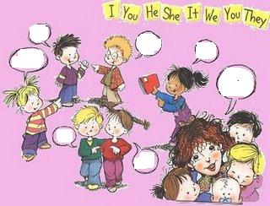

C-COMPLETE WITH ‘ am / is / are ‘

- I …………
- You ………….
- He …………..
- We…………
- She ………….
- It ……………
- They ……………

D-WRITE THE SHORT FORMS
- It is ………………
- They are ………………….
- I am ………………….. .
- We are ……………….
- He is ………………….
- You are ……………… .

E-COMPLETE THE DIALOGUES

- A:Hello! I ……..Mary.W…………..’s y…………… n………………..?
B:My ………………..’s John. ……………….are you?
A:………’m ……………., …………………you.

- C: Good morning,Jane.
D: ……………………………………… ,Mike.
How are you?
C: I’m fine,thank you,………………………?
D:…………………..,thanks.Good-bye.
C:…………………………… .

- E: What’s your name?
F:My name is ………………………….. .What’s your ……………………..?
E:………………………………………….. .
F:Nice …………. meet you,………………… .
E:Nice ………………………………………………..,too.

F-FILL IN THE BLANKS

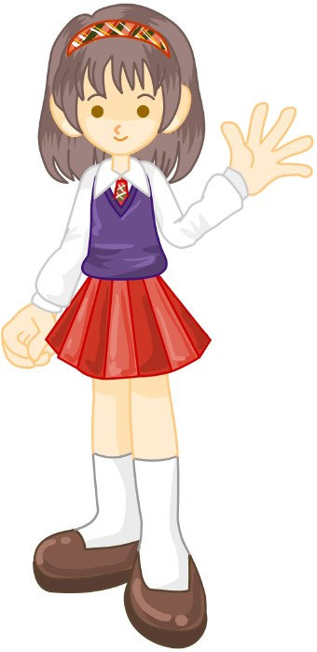
- What’s ……………………..name?
…………………name is Susan.

- What’s ……………………..name?
……………..name is Mırnav.

- What’s …………………..name?
……………….name is Mert.

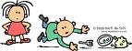
- What are ……………………..names?
……………….names are Carol and Joe.

- What’s ……………..name?
My …………………………………………………………… .

