Name: ____________________________ Surname: ____________________________ N^{ber}: ____ Grade/Class: _____
Assessment: _____________________________ | Date: ___________________________________________________
 | Teacher’s signature:  ___________________________ | Parent’s signature:  ___________________________

- Read the words and match the pictures.
Goodbye!
I’m fine!

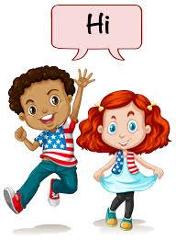
Hello!

Good night!

Good morning!

