Name: ____________________________ Surname: ____________________________ N^{ber}: ____ Grade/Class: _____
Assessment: _____________________________ | Date: ___________________________________________________ 1.
 | Teacher’s signature:  ___________________________ | Parent’s signature:  ___________________________

- Read and order the words.
_______________________________
are / you / how / ?
name / is / my / Pam
________________________________
________________________________

am / fine / I / thanks / , / .

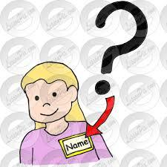
your / name / is / what / ?
_____________________________
_____________________________
is / my / surname / Peterson
___________________________
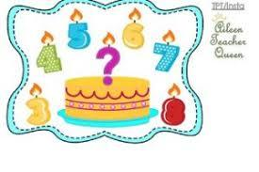
are / old / you / How / ?

Answer Key
How are you?
My name is Pam
I am fine, thanks.
What is your name?
My surnmae is Peterson.
How old are you?

