Name: ____________________________ Surname: ____________________________ N^{ber}: ____ Grade/Class: _____
Assessment: _____________________________ | Date: ___________________________________________________
 | Teacher’s signature:  ___________________________ | Parent’s signature:  ___________________________

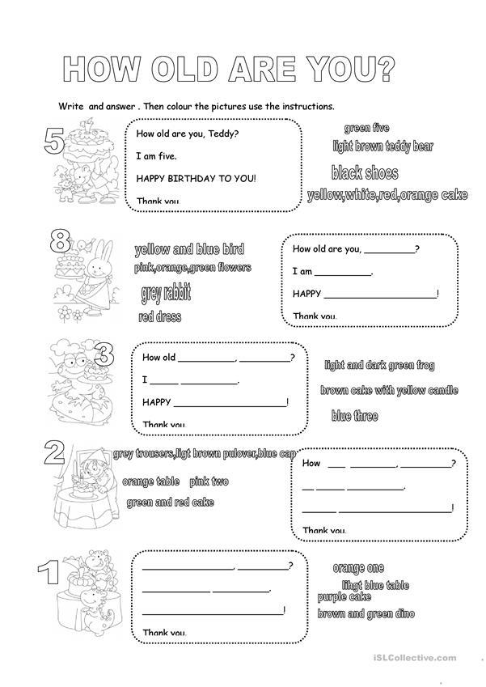
- Answer the questions and color the pictures as in the instructions.
PINK FIVE
BLACK SHOES

RED EIGHT
BLUE DRESS

BROWN THREE
GREEN FROG
GREEN ONE
ORANGE DINOSAUR
PURPLE TWO
YELLOW TABLE

