Name: ____________________________ Surname: ____________________________ N^{ber}: ____ Grade/Class: _____
Assessment: _____________________________ | Date: ___________________________________________________
 | Teacher’s signature:  ___________________________ | Parent’s signature:  ___________________________
- Read and complete the card

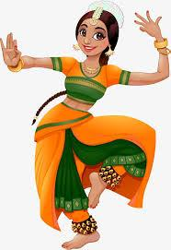
Good afternoon!
My name’s Anoushka Shankar. I’m from India. I’m Indian. I was born in 2006 and my birthday is in February. Nice to meet you

Name:
Surname:
Age:
Country:
Nationality:

_____ Take care!
_____ Hi! How are you?
_____ How are you?
_____ I’m fine thanks, and you?
_____ I’m ok, thanks.
_____ Ok, see you!

- Read and number. 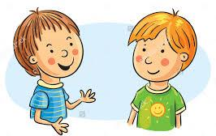

Answer Key
1.
Name: Anoushka
Surname: Shankar
Age:15
Country: India
Nationality: Indian

2.
___6__ Take care!
__1___ Hi! How are you?
___2__ How are you?
___3__ I’m fine thanks, and you?
___4__ I’m ok, thanks.
___5__ Ok, see you!

