Name: ____________________________ Surname: ____________________________ N^{ber}: ____ Grade/Class: _____
Assessment: _____________________________  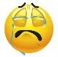  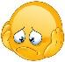  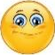 | Date: ___________________________________________________
 | Teacher’s signature:  ___________________________ | Parent’s signature:  ___________________________

- Read, put a tick (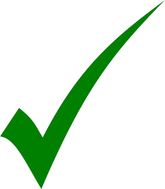) for the right answer or a cross (X) for the wrong answer.

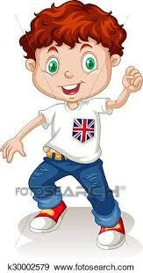
Hello! I’m David Sparks. I’m 13 years old. I’m from Britain, so I’m British. My birthday is in February. I’m wonderful. How are you?

- His name is Davud ______.
- His surname is Sparks _____.
- He is from India _____.
- He is American _____.
- He is thirteen years old _____.

- Read and order the words.
- is / My /in /June / birthday _________________________________________________.
- your / What / nationality / is ________________________________________________.
- a / Have / weekend / nice _________________________________________________.

Answer key

Hello! I’m David Sparks. I’m 13 years old. I’m from Britain, so I’m British. My birthday is in February. I’m wonderful. How are you?

- His name is Davud __X____.
- His surname is Sparks _____.
- He is from India __X___.
- He is American __X___.
- He is thirteen years old _____.

- Read and order the words.
- is / my /in /June / birthday ______My birthday is in June______.
- your / what / nationality / is ______What is your nationality?__________.
- a / Have / weekend / nice ______Have a nice weekend___________.

