Name: ____________________________ Surname: ____________________________ N^{ber}: ____ Grade/Class: _____
Assessment: _____________________________ | Date: ___________________________________________________
 | Teacher’s signature:  ___________________________ | Parent’s signature:  ___________________________
1. Read and answer the questions
TURKEY-TARKAN GREECE-KETI GARIBI

Where is Keti Garibi from?
……………………….
What nationality is she?
……………………….

Where are David Beckham and Victoria Beckham from?
……………………….
What nationality are they?
……………………….

Where is Anna Kournikova from?
……………………….
What nationality is she?
……………………….

Where is Husnu Mubarek from?
……………………….
What nationality is he?
……………………….

Where is Michael Schumaer from?
……………………….
What nationality is he?
……………………….

Where is Tarkan from?
……………………….
What nationality is he?
……………………….

Where are Michael Jackson and
Madonna from?
……………………….
What nationality are they?
……………………….

Where is Inatomo from?
……………………….
What nationality is he?
……………………….

Where is Raul Gonzales from?
……………………….
What nationality is he?
……………………….

Where is Pavorotti from?
……………………….
What nationality is he?
……………………….

THE USA-MICHAEL JACKSON,MADONNA ENGLAND-DAVID BECKHAM,VICTORIA BECKHAM

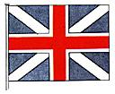

JAPAN-INATOMO RUSSIA-ANNA KORNIKOVA

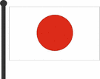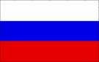

SPAIN-RAUL GONZALES EGYPT-HUSNU MUBAREK

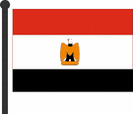

ITALY-PAVOROTTI GERMANY-MICHAEL SCHUMAER

