Name: ____________________________ Surname: ____________________________ N^{ber}: ____ Grade/Class: _____
Assessment: _____________________________ | Date: ___________________________________________________
 | Teacher’s signature:  ___________________________ | Parent’s signature:  ___________________________

- Find the differences.

Student A
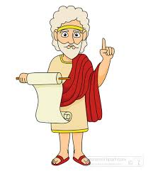

Claire Aimoto Atlas
28 years old 18 years old 65 years old
French Japanese Greek

- Find the differences.

Student B

Claire Aimoto Platon
30 years old 18 years old 65 years old
French Chinese Greek

