TOPIC: | SUBTOPICS: | LEVEL:
Name: ____________________________ Surname: ____________________________ N^{ber}: ____ Grade/Class: _____

How old …….?
Flavia
Marta (7)

How old are you?
_____________________
Tomas (6)
How old is Peter?
_____________________
How old is Flavia?
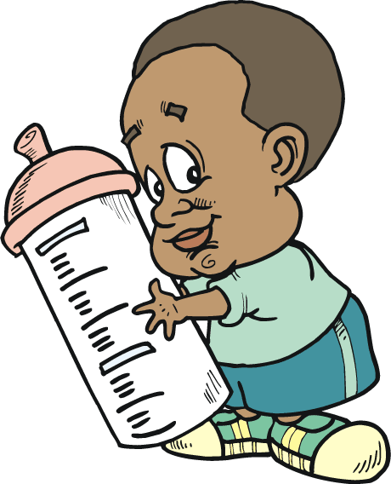
_____________________
Ezequiel (3)
How old is Silvia?
Maria (2)
_____________________
How old is Tina?
Patricia (8)
_____________________
How old is Tomas?
_____________________
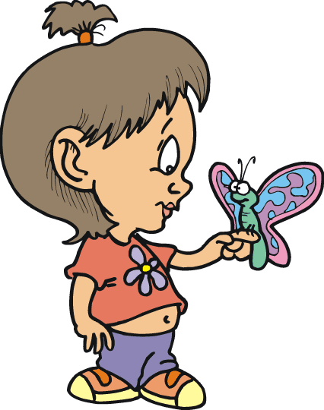
How old is Mariano?
Silvia
Tina (10)
_____________________
How old is Emilia?
_____________________

Paula (5)
How old is Ezequiel?
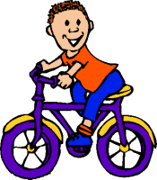
_____________________
Sebastián (4)
How old is Maria?
_____________________
How old is Marta?
Emilia (5)
_____________________
Mariano (9)
How old is Sebastian?
_____________________
How old is Paula?
Peter
_____________________
How old is Patricia?
_____________________

