Name: ____________________________ Surname: ____________________________ N^{ber}: ____ Grade/Class: _____
Assessment: _____________________________ | Date: ___________________________________________________
 | Teacher’s signature:  ___________________________ | Parent’s signature:  ___________________________
- Color the correct answer.
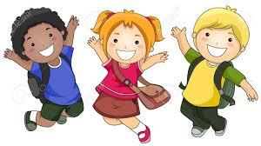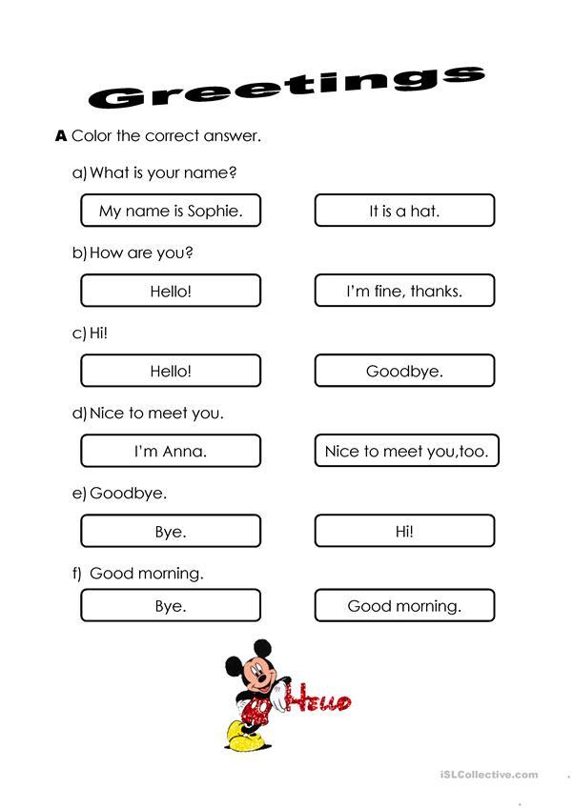
I’m Spanish.
Answer Key

