Name: ____________________________ Surname: ____________________________ N^{ber}: ____ Grade/Class: _____
Assessment: _____________________________  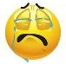  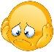 | Date: ___________________________________________________
 | Teacher’s signature:  ___________________________ | Parent’s signature:  ___________________________
- Circle the correct answer to label the pictures.
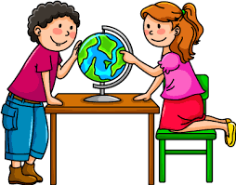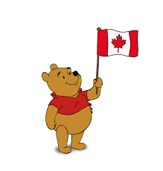
- How old are you? a. Where are you from? a. I’m Spanish.
- Nice to meet you! b. When is your birthday? b. Good afternoon!
- What’s your nationality? c. Hello! c. I’m from Canada.
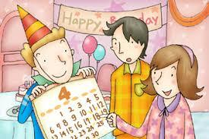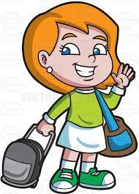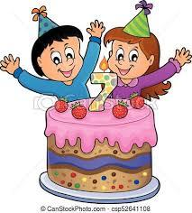

- When is your birthday? a. How are you? a. I’m seven years old.
- See you tomorrow! b. Take care! b. What’s your name?
- What’s your surname? c. I’m Chinese. c. Good night!
- Unscramble the letters
What nationality are you? I am U – K – I – H – T – R – S ________________
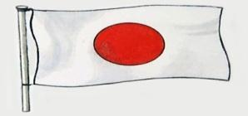 What nationality are you? I am E – J – P – A – E – N – S – A ________________
What nationality are you? I am H – I – C – E – N – E – S _________________
Answer Key
- Circle the correct answer to label the pictures.

- How old are you? a. Where are you from? a. I’m Spanish.

- Nice to meet you! b. When is your birthday? b. Good afternoon!
- What’s your nationality? c. Hello! c. I’m from Canada.

- When is your birthday? a. How are you? a. I’m seven years old.

- See you tomorrow! b. Take care! b. What’s your name?
- What’s your surname? c. I’m Chinese. c. Good night!
- Unscramble the letters
What nationality are you? I am U – K – I – H – T – R – S TURKISH
What nationality are you? I am E – J – P – A – E – N – S – A JAPANESE
What nationality are you? I am H – I – C – E – N – E – S CHINESE

