Name: ____________________________ Surname: ____________________________ N^{ber}: ____ Grade/Class: _____
Assessment: _____________________________ | Date: ___________________________________________________
 | Teacher’s signature:  ___________________________ | Parent’s signature:  ___________________________
Complete the blanks with the sentences in the box.
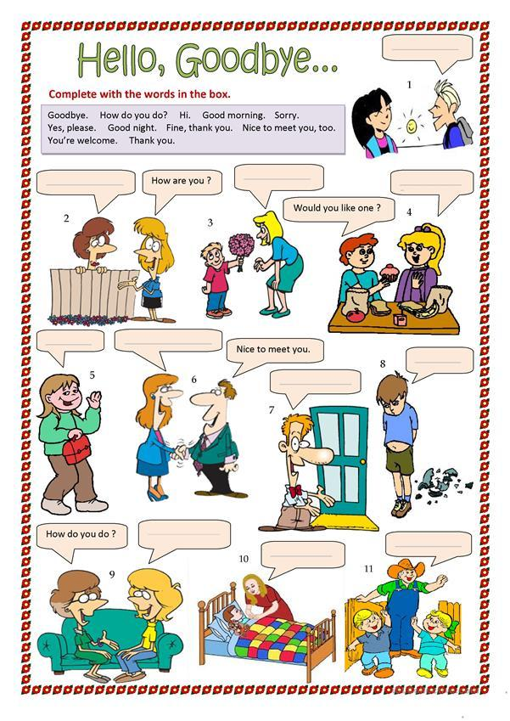

See you later.
I’m fine, thanks.
Good night.
Thank you.
Nice to meet you, too.
Goodbye.
It’s in July.
When is your birthday?
Answer Key

2. I’m fine, thanks
3. Thank you
5. Goodbye / See you later
6. Nice to meet you, too
9. It’s in July
10. Good night
11. See you later / Goodbye

