Name: ____________________________ Surname: ____________________________ N^{ber}: ____ Grade/Class: _____
Assessment: _____________________________ | Date: ___________________________________________________
 | Teacher’s signature:  ___________________________ | Parent’s signature:  ___________________________

- Write the correct greeting under the pictures.

______________________ ________________________ _______________________ ______________________
- Introduce the children and write in the bubbles. The first one is an example for you.
He is Sergio. He’s 9 years old and he’s Itallian, he’s from Italy.

Akira
Japanese
10 years old
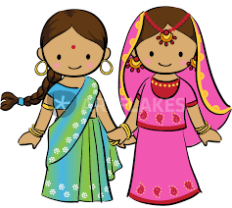
Anushka&Krisha
Indian
8 years old

Answer Key
- Write the correct greeting under the pictures.

Good monring Good night Hello Goodbye
- Introduce the children and write in the bubbles. The first one is an example for you.
He is Sergio. He’s 9 years old and he’s Itallian, he’s from Italy.

He is Akira. He is 10 years old. He is Japanese. He is from Japan.

They are Anushka&Krisha. They are 8 years old. They are from India. They are Indian.

