|  |  |  |
| --- | --- | --- |
| **TOPIC:** | **SUBTOPICS:** | **LEVEL:** |
| **Name:** ____________________________ **Surname:** ____________________________ **Nber: ____ Grade/Class:** _____ | | |

u10382831[1]u10382831[1]



1. **How old is Megan?**

**_____________________________**

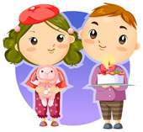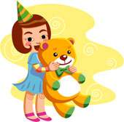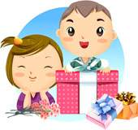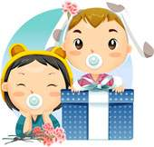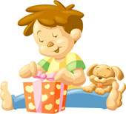

**Sally & Sam - 10**

**Carol - 11**

**Roy - 3**

**Julia & Mike - 9**

**Bia & Pepe - 2**

**Bart - 7**

1. **How old is Carol?**

**_____________________________**

1. **How old are Samuel and Sally?**

**_____________________________**

1. **How old are Julia and Mike?**

**_____________________________**

1. **How old is Roy?**

**_____________________________**

1. **How old is Bart?**

**_____________________________**

1. **How old are Bia and Pepe?**

**_____________________________**

1. **How old is Lisa?**

**_____________________________**

**Lisa - 5**

**Megan - 6**