TOPIC: | SUBTOPICS: | LEVEL:
Name: ____________________________ Surname: ____________________________ N^{ber}: ____ Grade/Class: _____

HOW OLD ARE YOU?

Write
12 11 18

I’m twelve I’m ___________ I’m ___________

HOW OLD ARE THEY?
Look and Answer

6 12 15 20
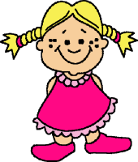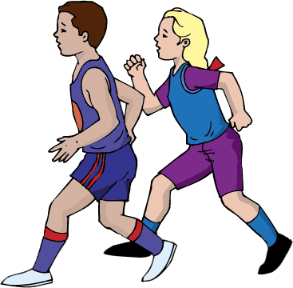

She’s___________ They’re___________ She’s___________ They’re___________

10 13 17 14
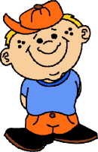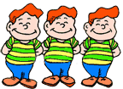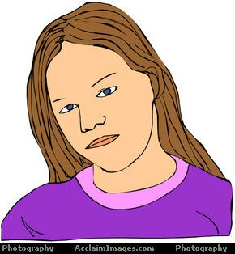
He’s _________ _ Are they eleven? Is she sixteen? Is he fourteen?
No, __________ No, __________ Yes,__________

Answer the questions.

- What’s your name?
___________________________________________
- How old are you?
___________________________________________
- Are you seven years old?
___________________________________________
4. How old is she?(15)
___________________________________________

