Name: ____________________________ Surname: ____________________________ N^{ber}: ____ Grade/Class: _____
Assessment: _____________________________ | Date: ___________________________________________________
 | Teacher’s signature:  ___________________________ | Parent’s signature:  ___________________________

- Fill in the blanks.
Hello, ____ _________ Elsa.
I’m _______________. (Country-Norway)
__________________________. (Age-18)
My birthday is in ____________ (Month-12th month)
They’re ___________________ (Who?)
They ‘re in Norway now.
___________________ a good family.
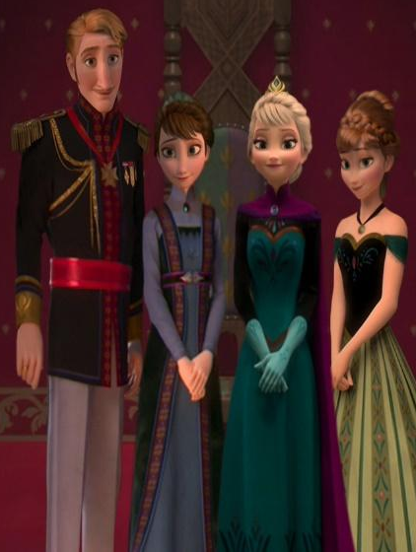

- Write a short to introduce yourself and your friend.

Draw your family here
Me

________________________________________________________________________________.

My friend

Draw your friend’s family

___________________________________________________________________________________________________________________________________________________________________________________________________________________________________________________________________________________________________________________________________.

Months of the Year
1.January 2. February 3. March 4. April 5. May 6. June
7. July 8. August 9. September 10. October 11. November 12. December

Answer Key
Hello, I am Elsa.
I’m from Norway. (Country-Norway)
I am 18 years old. (Age-18)
My birthday is in December (Month-12th month)
They’re my family (Who?)
They ‘re in Norway now.
We are a good family.
1.

