Name: ____________________________ Surname: ____________________________ N^{ber}: ____ Grade/Class: _____
Assessment: _____________________________ | Date: ___________________________________________________
 | Teacher’s signature:  ___________________________ | Parent’s signature:  ___________________________

Read the text, then listen and color and mark according to the instructions.
This is Anna. She is a hairdresser. She cuts and colors hair. She works in a hair salon. She uses scissors to cut hair. She puts a cape on her customer before she cuts their hair, so they don’t get hair on their clothes.

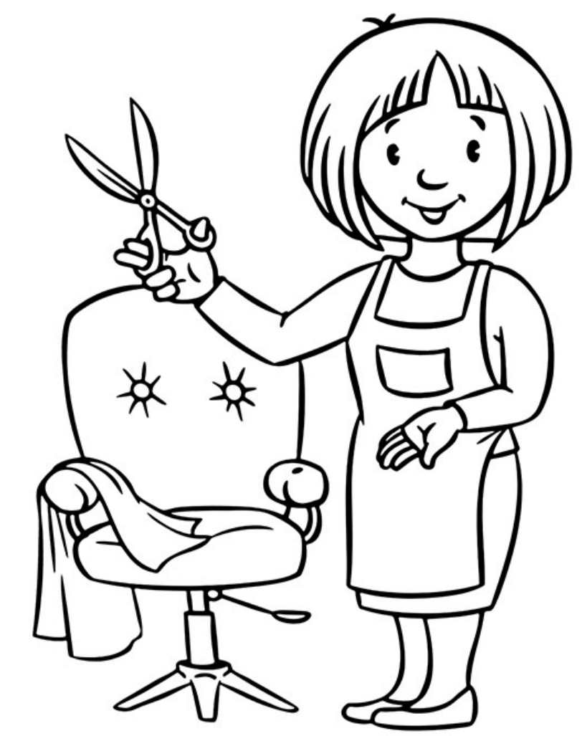

Transcript:
- The chair is red.
- Anna’s hair is brown.
- The scissors are grey.
- Anna’s apron is blue.
- Anna’s shoes are black.
- The cape is white.
- Anna’s shirt is green.
- Anna’s shoes are yellow.
- Draw a circle around the scissors.
- Cross over the cape.

