Name: ____________________________ Surname: ____________________________ N^{ber}: ____ Grade/Class: _____
Assessment: _____________________________ | Date: ___________________________________________________
 | Teacher’s signature:  ___________________________ | Parent’s signature:  ___________________________

Listen and add the correct numbers from 1 to 9 in the boxes.
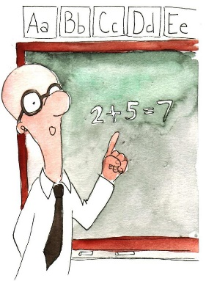
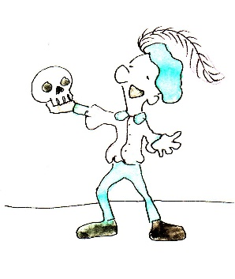

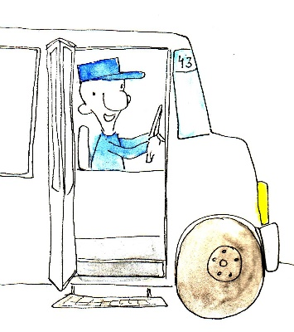
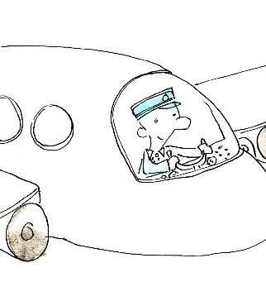

Transcript:
- Doctor
- Mailman
- Bus driver
- Actor
- Chef
- Pilot
- Writer
- Businessman
- Teacher

