Name: ____________________________ Surname: ____________________________ N^{ber}: ____ Grade/Class: _____
Assessment: _____________________________ | Date: ___________________________________________________
 | Teacher’s signature:  ___________________________ | Parent’s signature:  ___________________________

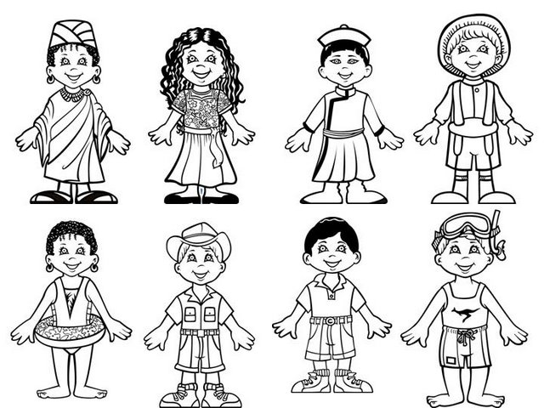
Listen and add the number in the box.

Transcript:
Number one is a doctor. Her name is Molly. She is wearing a hat and earrings.
Number two is a snorkler. His name is Mark. He is wearing a shirt with a kangaroo picture.
Number three is a swimmer. Her name is Jane. She is wearing a swimsuit and earrings.
Number four is a waiter. His name is Yuko. He has dark hair and a hat.
Number five is a dancer. Her name is Anna. She has long dark hair and is wearing a dress.
Number six is a teacher. His name is Tom. He has dark hair and is wearing boots.
Number seven is a farmer. His name is John. He is wearing a hat.
Number eight is a vet. His name is Ben. He is wearing a shirt with pockets and a hat.

