Name: ____________________________ Surname: ____________________________ N^{ber}: ____ Grade/Class: _____
Assessment: _____________________________ | Date: ___________________________________________________
 | Teacher’s signature:  ___________________________ | Parent’s signature:  ___________________________

Listen and write true or false.
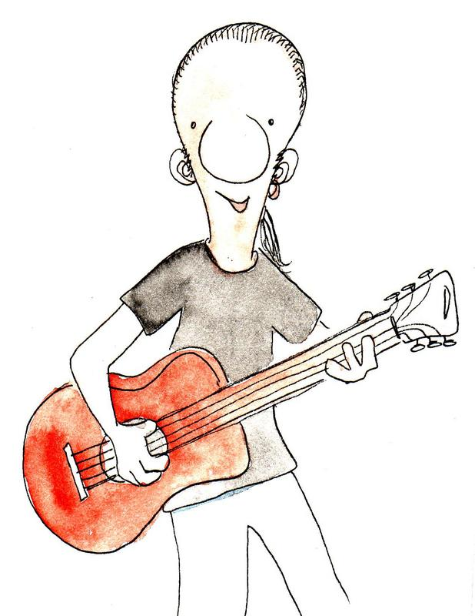

His name is Trevor. _____________
He lives in Dublin. _____________
He is a musician. _____________
He plays three instruments. _____________
Today he is playing the piano. _____________
He is a good guitar player. _____________

Transcript:
This is Trevor.
He is English and lives in London.
Trevor is a musician.
He plays two instruments: guitar and piano.
Today he is playing the guitar
He is a very good guitar player.

