Name: ____________________________ Surname: ____________________________ N^{ber}: ____ Grade/Class: _____
Assessment: _____________________________ | Date: ___________________________________________________
 | Teacher’s signature:  ___________________________ | Parent’s signature:  ___________________________

Color the picture according to the instructions and answer the questions.
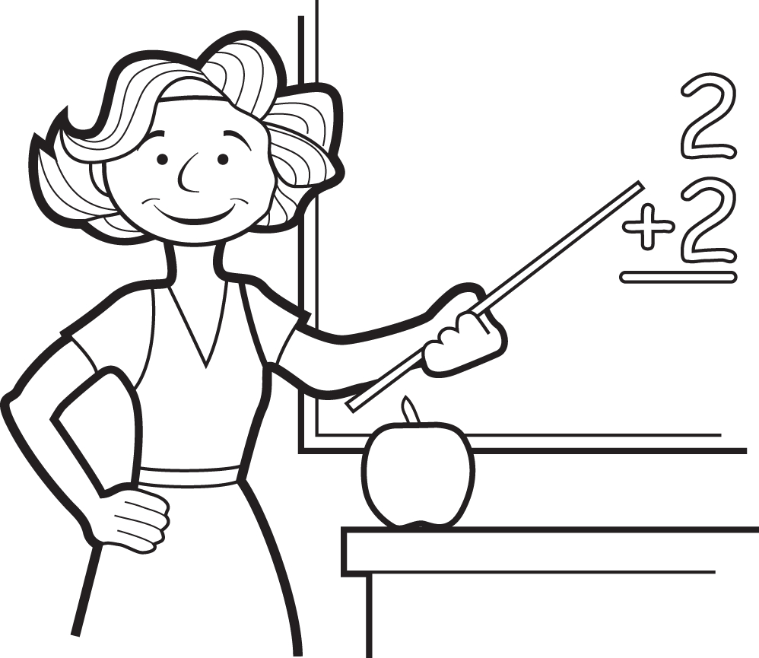

- What is her name? ________________________________________________
- What is her job? ________________________________________________
- How old is she? ________________________________________________
- Where does she live? ________________________________________________
- Where does she work? ________________________________________________
This is Helen.
Helen is a teacher.
She is 29 years old.
She lives in Helsinki, Finland.
She works in a school.

Color Helen’s hair red.
Color Helen’s dress blue.
Color the numbers on the board purple.
Color the apple red.
Color the pointer brown.
Color the desk green.

