Name: ____________________________ Surname: ____________________________ N^{ber}: ____ Grade/Class: _____
Assessment: _____________________________ | Date: ___________________________________________________
 | Teacher’s signature:  ___________________________ | Parent’s signature:  ___________________________

Read the text and answer the questions.
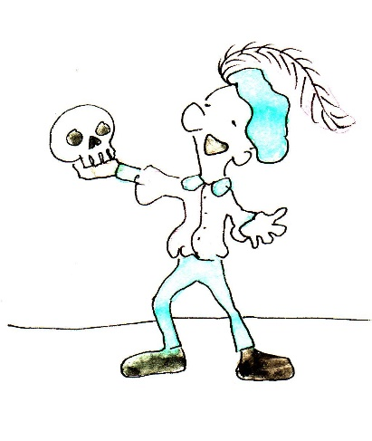

This is Peter. Peter is 27 years old. He lives in London, England. Peter is an actor. He works in a theatre. He loves to act and plays many different parts. He also teaches acting to other people.
Peter lives in a small house with only one bedroom. He has a big black dog. The dog is called Buster. He walks the dog every day for an hour in the morning and for an hour after he comes home from work.

What is peter’s job? ___________________________________________________________
How old is Peter? ___________________________________________________________
Where is he living? ___________________________________________________________
Where is he working? ___________________________________________________________
What is he teaching? ___________________________________________________________
When is he walking the dog? ___________________________________________________________

