Name: ____________________________ Surname: ____________________________ N^{ber}: ____ Grade/Class: _____
Assessment: _____________________________ | Date: ___________________________________________________
 | Teacher’s signature:  ___________________________ | Parent’s signature:  ___________________________
Read the text and answer the questions.

Hello! My name is Jack. I am 28 years old I live in Seattle; USA and I am a firefighter. In the morning, I wake up early at half past five. I take a shower; I get dressed and I go to work at a quarter past six.
I save people by putting out fires in dangerous situations. We use a long hose to spray water on buildings that are on fire. I like to drive the fire truck. The fire truck has long ladder that we use when we have to reach high up to a window in a building or when we save a cat from a high tree,
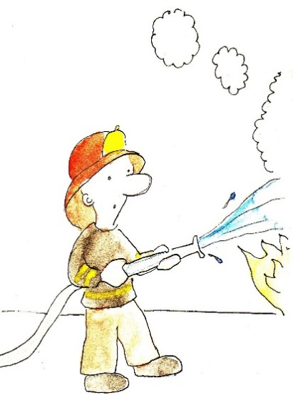
I wear special heat resistant clothes that protect myself from fires. I also wear a helmet and boots. And I carry an axe, a flash light, a knife, wire cutters and a screw driver.
Jacks job is dangerous, but he loves it. He is a hero...

- What is his name? __________________________________

- How old is he? __________________________________

- What time does he get up? __________________________________

- What time does he go to work? __________________________________

- What does he do? __________________________________

- What does he use at work? __________________________________

- What does he wear at work? __________________________________

- What does he carry with him?

- What does he drive? __________________________________

- Does Jack like his job? __________________________________

- Does he wear sneakers at work? __________________________________

- Where does Jack live? __________________________________

Key:
- Jack
- 28 years old
- Half past five in the morning
- He goes to work at a quarter past six
- He is a firefighter
- He uses a hose
- Special heat resistant clothes, helmet and boots
- He carries an axe, a flash light, a knife, wire cutters and a screw driver.
- He drives a fire truck
- Yes, he loves his job
- No, he wears boots
- He lives in Seattle, USA

