Name: ____________________________ Surname: ____________________________ N^{ber}: ____ Grade/Class: _____
Assessment: _____________________________ | Date: ___________________________________________________
 | Teacher’s signature:  ___________________________ | Parent’s signature:  ___________________________

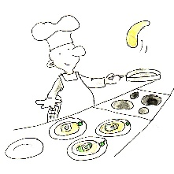
Read, write and match.

- I learn my lines and perform in theatres.
____________________

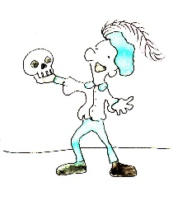

- I wear a suit and work in an office.
____________________

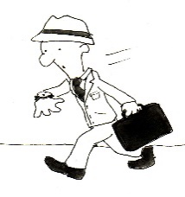

- I am responsible for everything regarding food in a restaurant.
____________________

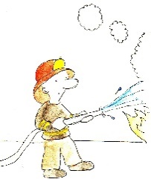

- I show stories and ideas with dance performances.
____________________

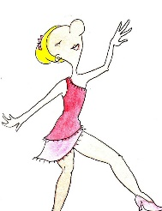

- I grow plants and raise animals on a farm.
____________________

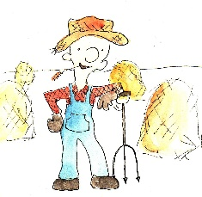
- My job is to put out fires and rescue people.
____________________

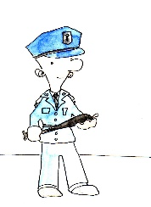

- I am a person who is trained to fly an aircraft or a spacecraft.
____________________

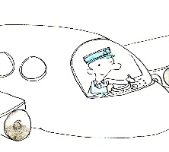
- I arrest criminals, protect and help the public
____________________

