Name: ____________________________ Surname: ____________________________ N^{ber}: ____ Grade/Class: _____
Assessment: _____________________________ | Date: ___________________________________________________
 | Teacher’s signature:  ___________________________ | Parent’s signature:  ___________________________

Read write and match.

- I use my voice to give a musical performance.
____________________

- I am a person who helps students to learn different things.
____________________

- I check animals and give them medical treatment.
____________________

- I take orders and deliver food to customers.

____________________

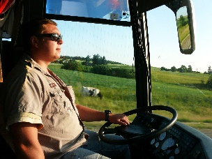
- I write books, articles, stories.

____________________

- I transport people where they need to go.
____________________

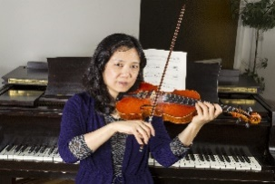
- I kick a ball in front of many people and make goals.
____________________

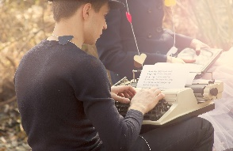

- I write, record, and perform music.
____________________

