Name: ____________________________ Surname: ____________________________ N^{ber}: ____ Grade/Class: _____
Assessment: _____________________________ | Date: ___________________________________________________
 | Teacher’s signature:  ___________________________ | Parent’s signature:  ___________________________
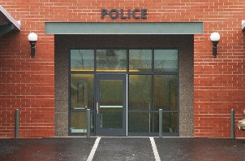

Read, write and match.

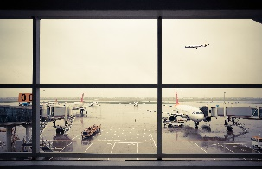
Example:
I pick up a package from here.
Post office

- I wear a badge and a uniform here.
____________________

- If I break my wrist, I must go here to get a cast.
____________________

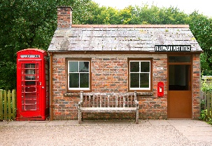

- I take care cows, chickens, and pigs. a.
____________________

- This is where people call if there is a dangerous fire.
____________________

- I work on the computer here and complete tasks.
____________________

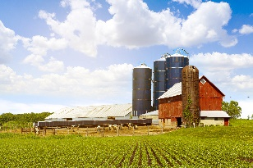
- I learn how to dance here.
____________________

- This is where planes land and take off.
____________________

