Name: ____________________________ Surname: ____________________________ N^{ber}: ____ Grade/Class: _____
Assessment: _____________________________ | Date: ___________________________________________________
 | Teacher’s signature:  ___________________________ | Parent’s signature:  ___________________________
Read the text and answer the questions.
This is William. He is 45 years old and married to Anne. He works as a mail man. William gets up at half past five in the morning. He takes a shower and puts on his clothes. William wears a uniform for work.
He eats breakfast at six. At seven o’clock, he drives to work.
William starts work at half past seven o’clock. His job is to deliver mail and parcels to homes and businesses. He drives a special truck which carries many things, all the mail and parcels that need to be delivered. He will visit your home 5 to 6 days a week. People like to see him because he usually brings something good. He is afraid of dogs but not cats. The bad weather does not stop him.
At twelve o’clock William eats lunch. He likes to eat fish and potatoes. After a busy day delivering mail and going through all the different neighborhoods, he drives home at five o’clock. At home, he takes a shower and cooks dinner for him and Anne. They eat dinner at half past six in the evening. Then, they like to watch TV. At eleven o’clock, William goes to bed
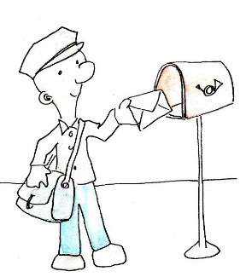
- What is his name? __________________________________

- How old is he? __________________________________

- What is his job? __________________________________

- Does he eat breakfast at seven o’clock? __________________________________

- Can he drive a car? __________________________________

- What does his job involve? __________________________________

- What does the truck carry? __________________________________

- What time does he have lunch? __________________________________

- What kind of vehicle does he drive at work? __________________________________

- What is the name of his wife? __________________________________

- What time do they have dinner? __________________________________

- What do they like to do before going to bed? __________________________________

Key:
- William
- 45 years old
- He is a mailman
- No, he eats breakfast at 6 am
- Yes, he can drive a car
- His job is to deliver mail and parcels to homes and businesses.
- Mail and parcels
- He eats lunch at twelve o’clock
- He drives a special truck
- Anne
- They eat dinner at half past six
- They like to watch TV.

