Name: ____________________________ Surname: ____________________________ N^{ber}: ____ Grade/Class: _____
Assessment: _____________________________ | Date: ___________________________________________________
 | Teacher’s signature:  ___________________________ | Parent’s signature:  ___________________________

Read the text and answer the questions.

This is Max. He is 29 years old and he is a police officer. Max gets up at seven o’clock in the morning. He takes a shower and puts on his clothes. Max wear a special uniform, hat, and a badge.
Then he eats breakfast at half past seven. At eight o’clock, he drives to work.
Max starts work at half past eight. Max loves his job! His job is one of the most dangerous because his mission is to keep everyone safe. He carries a walkie-talkie and a baton, and he is also armed.
At one o’clock, Max has lunch. He likes to eat chicken with rice. After a busy day at the station, he goes home at six o’clock.
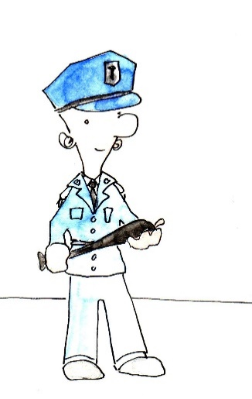
At home, he takes a shower and cooks dinner. He has dinner at half past six in the evening. Then, he likes to watch TV. At ten thirty o’clock, Max goes to bed. He brushes his teeth and reads a book for a while before falling asleep.

- What is his name? __________________________________

- How old is he? __________________________________

- What is his job? __________________________________

- Does he eat breakfast at seven o’clock? __________________________________

- Can he drive a car? __________________________________

- What does his job involve? __________________________________

- What does he carry on him while he is working? __________________________________

- What time does he have lunch? __________________________________

- Is his job dangerous? __________________________________

- What time does he have dinner? __________________________________

- What does he like to do before going to bed? __________________________________

- What does he do before going to sleep? __________________________________

Key:
- Max
- 29
- Police officer
- No, he eats breakfast at 7.30am
- Yes
- To keep everyone safe
- A walkie-talkie, a baton and a gun (firearm)
- 1 o’clock
- Yes
- 6.30pm
- He likes to watch TV
- He brushes his teeth and reads a book

