Name: ____________________________ Surname: ____________________________ N^{ber}: ____ Grade/Class: _____
Assessment: _____________________________ | Date: ___________________________________________________
 | Teacher’s signature:  ___________________________ | Parent’s signature:  ___________________________

Read the text and answer the questions.

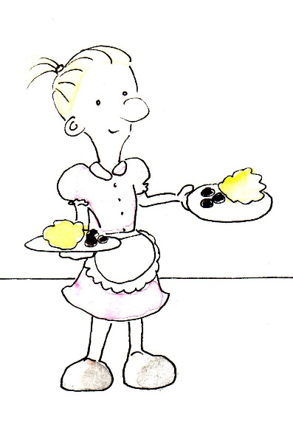
This is Annie. Annie works in a restaurant. She is a waitress. She works in a restaurant. She asks what the customers want and then she brings the food to them. She wears a pink uniform and an apron when she works. She needs to wear comfortable shoes when she works, otherwise her feet will be sore after her shift. She speaks three languages. Spanish, English, and Italian. She has blonde hair and blue eyes. She is married to Andy. Andy works in the same restaurant. He is a also a waiter.

What is Annie’s job? ______________________________________________________
Where is she working? ______________________________________________________
What is she wearing at work? ______________________________________________________
What languages can she speak? ______________________________________________________
What color are her eyes? ______________________________________________________
Who is she married to? ______________________________________________________

