Name: ____________________________ Surname: ____________________________ N^{ber}: ____ Grade/Class: _____
Assessment: _____________________________  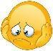 | Date: ___________________________________________________
 | Teacher’s signature:  ___________________________ | Parent’s signature:  ___________________________

Look at the picture and guess what jobs the children have. Give each child a name and draw a line from the name to the child. Then answer the questions.

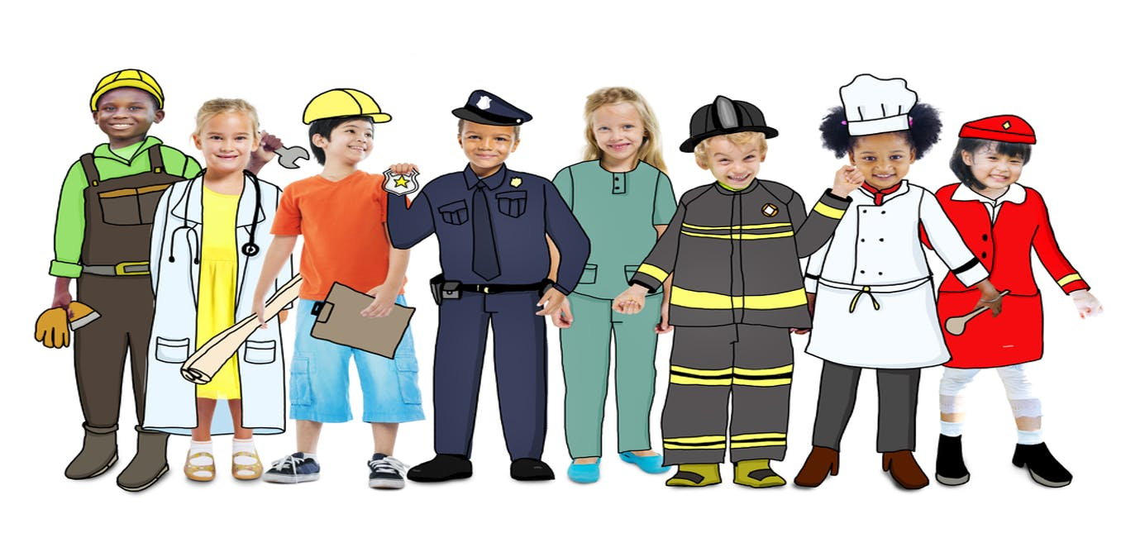

How old do you think the children are?
Does anyone have blue shoes?
Does anyone have orange pants?
Does anyone have blonde hair?
Does anyone smile?
Is anyone sad?
Does anyone have a hat?
Does anyone have a green jacket?

