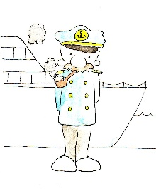
Name: ____________________________ Surname: ____________________________ N^{ber}: ____ Grade/Class: _____
Assessment: _____________________________ | Date: ___________________________________________________
 | Teacher’s signature:  ___________________________ | Parent’s signature:  ___________________________
Look at the pictures and make a sentence. Answer for you and for your friend Tony.
Example: I am a captain. Tony isn’t a captain.
YOU Tony
