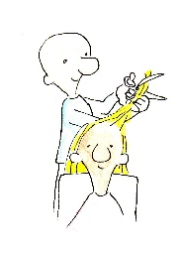
Name: ____________________________ Surname: ____________________________ N^{ber}: ____ Grade/Class: _____
Assessment: _____________________________  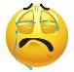  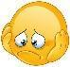 | Date: ___________________________________________________
 | Teacher’s signature:  ___________________________ | Parent’s signature:  ___________________________
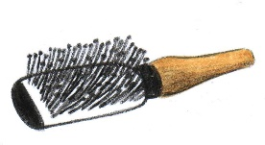
Match the items with the correct job and talk about what they do with them. +
Example: A hairdresser is using a hairbrush to brush hair with.
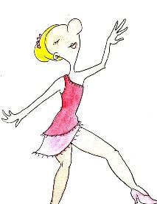
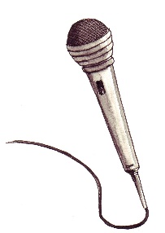

A.

- =
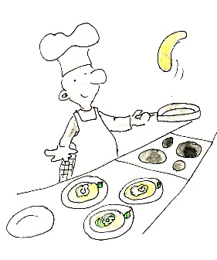
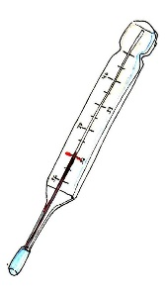

B.
2. =
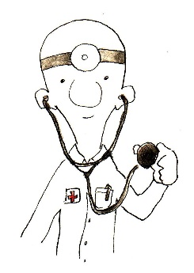
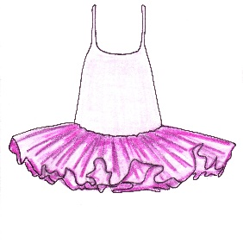

C.
3. =
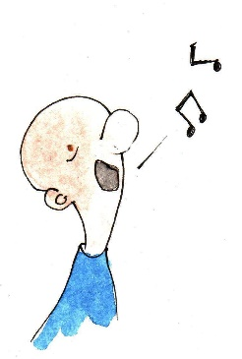
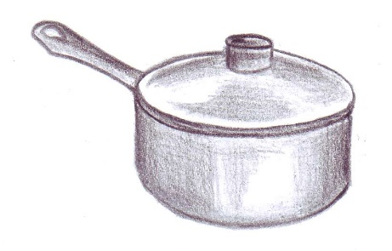

D.
4. =

