Name: ____________________________ Surname: ____________________________ N^{ber}: ____ Grade/Class: _____
Assessment: _____________________________ | Date: ___________________________________________________
 | Teacher’s signature:  ___________________________ | Parent’s signature:  ___________________________

Look at the pictures and talk about what the children’s parents do as their job.
Example: Lisa’s mother is a chef and her father is a teacher. Her mother cooks food in a restaurant and her father teaches art in a school.
Tina Adam
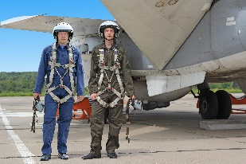
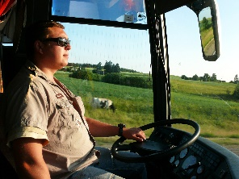

Paul Jenny

Answer the questions

What does your mother do?
Where does she work?
What does your father do?
Where does he work?
What would you like to do when you grow up?
Where would you like to work?
Would you like to work where you live now or would you like to move somewhere else?

