Name: ____________________________ Surname: ____________________________ N^{ber}: ____ Grade/Class: _____
Assessment: _____________________________ | Date: ___________________________________________________
 | Teacher’s signature:  ___________________________ | Parent’s signature:  ___________________________

Look at the picture and speak about the jobs the children want to do when they grow up.
Example: Jane wants to be a nurse and work in a hospital.
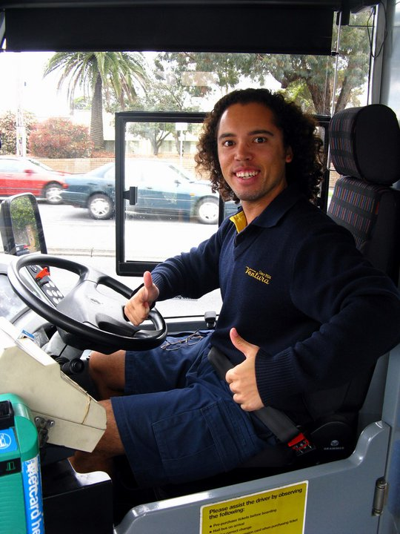
Jane. Daniel. James.

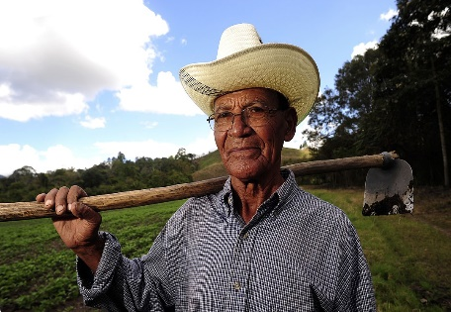
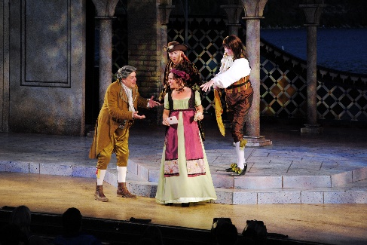
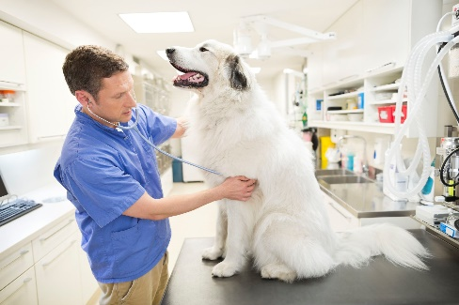
Tom. Michael. Paula.
This Photo by Unknown Author is licensed under CC BY-SA

What would you like to do when you grow up?

