Name: ____________________________ Surname: ____________________________ N^{ber}: ____ Grade/Class: _____
Assessment: _____________________________ | Date: ___________________________________________________
 | Teacher’s signature:  ___________________________ | Parent’s signature:  ___________________________
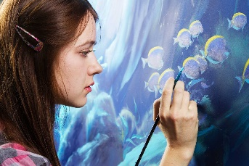
Look at the pictures and talk about what his /her job is. What do they do?
What do they like doing?
Example: The artist is painting blue flowers. She likes to paint.
