Name: ____________________________ Surname: ____________________________ N^{ber}: ____ Grade/Class: _____
Assessment: _____________________________ | Date: ___________________________________________________
 | Teacher’s signature:  ___________________________ | Parent’s signature:  ___________________________
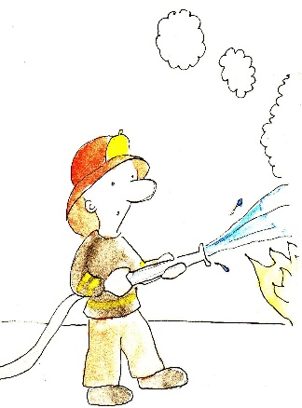
What is their job? What does he/she do? Ask questions and give answers
Example:
He is a musician. He plays the guitar.

