Name: ____________________________ Surname: ____________________________ N^{ber}: ____ Grade/Class: _____
Assessment: _____________________________ | Date: ___________________________________________________
 | Teacher’s signature:  ___________________________ | Parent’s signature:  ___________________________

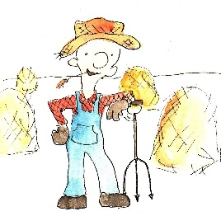
Match the jobs with the descriptions and draw a line to the correct picture.

A chef / A baker / A farmer/ A doctor / A mailman / A pilot / A teacher / A zookeeper/

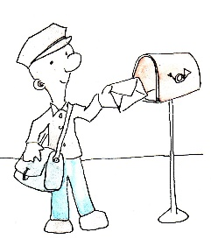
- I fly airplanes so you can visit other countries.
I am __________________________________
- I help people who are not feeling well, I give them medicine.
I am __________________________________
- I look after animals, I feed them and take care of them.
I am __________________________________
- I work with children. I teach them to read and write.
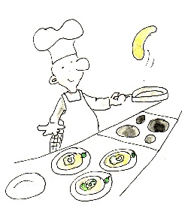
I am __________________________________
- I make bread, cookies and cakes.
I am __________________________________
- I bring you your mail.
I am __________________________________
- I work with animals and grow vegetables.
I am __________________________________
- I cook food in a restaurant.
I am __________________________________

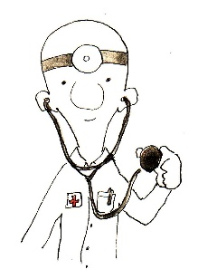
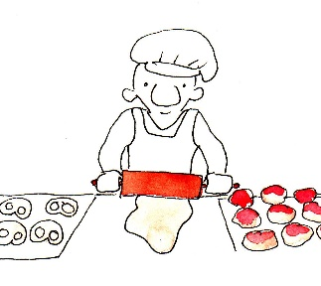

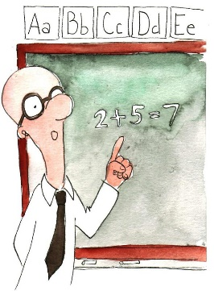
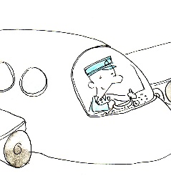
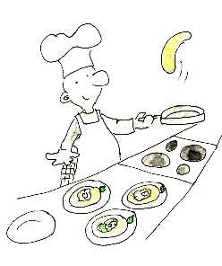
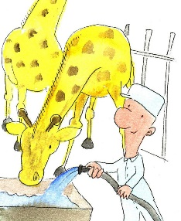

Key:
- Pilot
- Doctor
- Zookeeper
- Teacher
- Baker
- Mailman
- Farmer
- Chef

