Name: ____________________________ Surname: ____________________________ N^{ber}: ____ Grade/Class: _____
Assessment: _____________________________ | Date: ___________________________________________________
 | Teacher’s signature:  ___________________________ | Parent’s signature:  ___________________________

1) Look at the pictures, fill in the gaps and circle the correct answer.

a)
Do you want to be a _ _ _ t _ _?
Yes, I do. / No, I don’t.
Yes, I do. / No, I don’t.

b)
Do you want to be a _ _ i _ _ _?

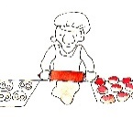
c)
Do you want to be a _ _ k _ _?
Yes, I do. / No, I don’t.

d)
Do you want to be a _ o_ k _ _ p _ _ ?
Yes, I do. / No, I don’t.
Yes, I do. / No, I don’t.

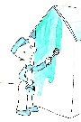
e)
Do you want to be a _ _ i _ _ _?

f)
Do you want to be a _ _ _ i _ _ m _ _?
Yes, I do. / No, I don’t.

Yes, I do. / No, I don’t.

g)
Do you want to be a _ _ n _ _ _ ?

