Name: ____________________________ Surname: ____________________________ N^{ber}: ____ Grade/Class: _____
Assessment: _____________________________ | Date: ___________________________________________________
 | Teacher’s signature:  ___________________________ | Parent’s signature:  ___________________________
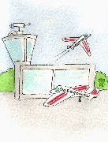
- Write the workplace on the empty lines, then add the correct letter in the boxes.
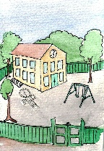
Restaurant / Post office / Airport/ Zoo/ Farm / Hospital / School

- Stamps, envelopes, packages ________________________________

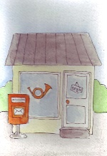
- Cows, chickens, vegetables ________________________________

- Medicine, stethoscope, face mask ________________________________
- Blackboard, chalk, books ________________________________

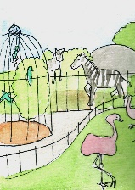
- Planes, runway, shops ________________________________

- Tables, food, drinks ________________________________

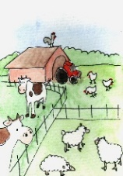
- Gorillas, bears, tigers ________________________________

- Who works there?

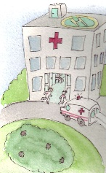
- _______________________ b. _______________________
c. _______________________ d. _______________________
e. _______________________ f. _______________________
g. _______________________

Key:
- Post office
- Farm
- Hospital
- School
- Airport
- Restaurant
- Zoo

- A mailman
- A farmer
- A doctor / a nurse
- A teacher
- A pilot / a stewardess
- A waiter / a chef / a cook
- A zookeeper

